**LAPORAN PRAKTIKUM**

**CSS PADA WEB**

**PEMROGRAMAN WEB**



**Disusun oleh :**

Kaisar Bagus S

201601047

**Dosen Pengampu :**

Oskar Ika Adi Nugroho., S.T.,M.T.

**JURUSAN SISTEM INFORMASI**

**SEKOLAH TINGGI ILMU KOMPUTER “YOS SUDARSO”**

**PURWOKERTO**

**2019**

1.source code HTML.

<!DOCTYPE html>

<html>

<head>

<title> Tugas 1 </title>

<link rel ="stylesheet" type="text/css" href="nomor1.css">

</head>

<body>

<div class="box">

<div class="square1 square1">

<div class="square2 square2">

<font size="5px"> go beyond plus ultra .

</font>

</div>

</div>

</div>

</body>

</html>

Source code CSS

body{

background: red;

text-align: center;

}

.box{

width: 1150px;

}

.kotak1{

width: 300px;

height: 185px;

padding: 15px;

background:rgb(155, 233, 232);

}

.kotak2{

width: auto;

height: 185px;

margin:5px 5px 5px 5px;

background: rgb(255, 255, 255);

border-radius: 20px 20px 20px 20px;

}

Output

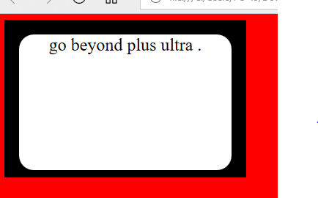

2.source code HTML.

<!DOCTYPE html>

<html lang="en">

<head>

<title>Tugas 2</title>

<link rel="stylesheet" type="text/css" href="nomer2.css">

</head>

<body>

<div class="octagon">

<div class="teksnya">

STIKOM YOS SUDARSO

</div>

</div>

</body>

</html>

Source code CSS

.octagon {

width: 200px;

height: 155px;

background: rgb(59, 0, 232);

position: relative;

margin:0 auto;

}

.octagon .teksnya{

color: rgb(233, 53, 53);

padding-top : 15%;

margin: 10%;

text-align: justify;

}

.octagon:before {

content: "";

position: absolute;

top: 0;

left: 0;

border-bottom: 20px solid rgb(155, 233, 232);

border-left: 20px solid azure;

border-right: 20px solid azure;

width: 80%;

height: 0;

}

.octagon :after {

content: "";

position : absolute;

bottom : 0;

left: 0;

border-top: 20px solid rgb(2, 23, 27);

border-left: 20px solid azure;

border-right: 20px solid azure;

width: 80%;

height : 0;

}

Output

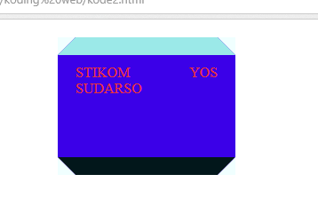

3.source code HTML.

<!DOCTYPE html>

<html>

<head>

<title> Tugas 3</title>

</head>

<style>

.container {

width: 300px;

height: 200px;

margin: 0 auto;

background-image: repeating-linear-gradient(135deg, green 0px,blue 15px, pink 15px, red 25px,

rgb(0, 162, 255) 25px, rgb(162, 0, 255) 40px, white 40px, white 50px);

padding: 12px;

}

.container .inner {

background: white;

width: 300px;

height: 200px;

}

</style>

<body>

<div class="container">

<div class="inner">

From all might,california

</div>

</div>

</body>

</html>

Output

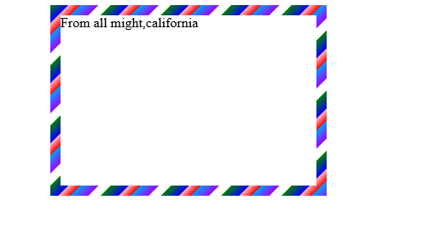

4.source code HTML.

<!DOCTYPE html>

<html>

<head>

<meta name="viewport" content="width=device-width, initial-scale=2">

<style>

.parallelogram {

float: left; align: center; padding:10px; margin:5px;

width: 170px; height: 40px; transform: skew(25deg);

background: #d48e33;

}

.parallelogram2 {

float: left; align: center; padding:10px; margin:5px;

width: 190px; height: 40px; transform: skew(25deg);

background: #878e9c;

}

.tulisan {

font : 20px Arial red; align: center; margin:5px;

color : red; width: 150px; height: 15px;

transform: skew(-25deg);

}

.tulisan2 {

font : 20px Arial red; align: center; margin:5px;

color : red; width: 170px; height: 15px;

transform: skew(-25deg);

}

</style>

</head>

<body>

<div class="parallelogram" >

<div class="tulisan"> <B >yos sudarso</B>

</div>

</div>

<div class="parallelogram2">

<div class="tulisan"> <B>academia</B>

</div>

</div>

</body>

</html>

Output

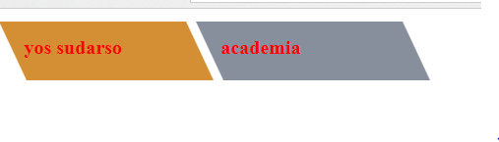

5.source code HTML.

<html lang="en">

<head>

<title>kode5</title>

<link rel="stylesheet" type="text/css" href="nomer5.css">

</head>

<body>

<div class="diagram">

<div class="dig" style="background-color: inherit;transform: rotate(.2turn);"></div>

</div>

<div class="diagram">

<div class="dig" style="background-color: rgb(155, 233, 175);transform:rotate(.1turn);"></div>

</div>

</body>

</html>

Source code CSS

.diagram{

float: left;

margin: 5px;

width: 100px;

height: 100px;

border-radius: 50%;

background-image: linear-gradient(to right, transparent 50%, rgb(118, 221, 22) 0);

}

.diagram .dig {

content: '';

display: block;

margin-left: 50%;

height: 100%;

border-radius: 0 100% 100% 0 / 50%;

transform-origin: left

}

Output

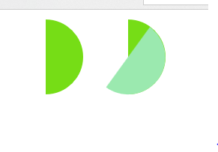

**Membuat repository baru**

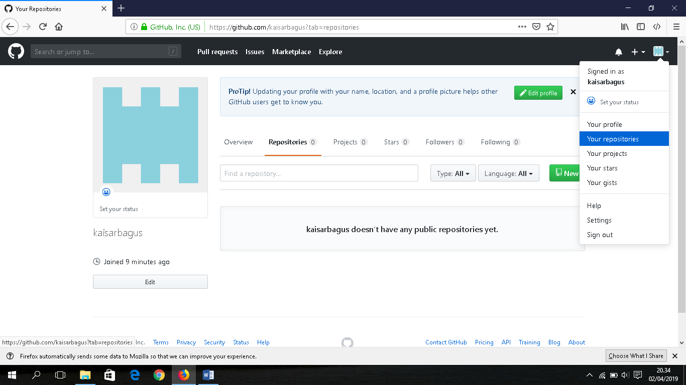

**Beri nama Modul03 dan centang *initialize this repository with a README.* Kemudian pilih *Create repository.***

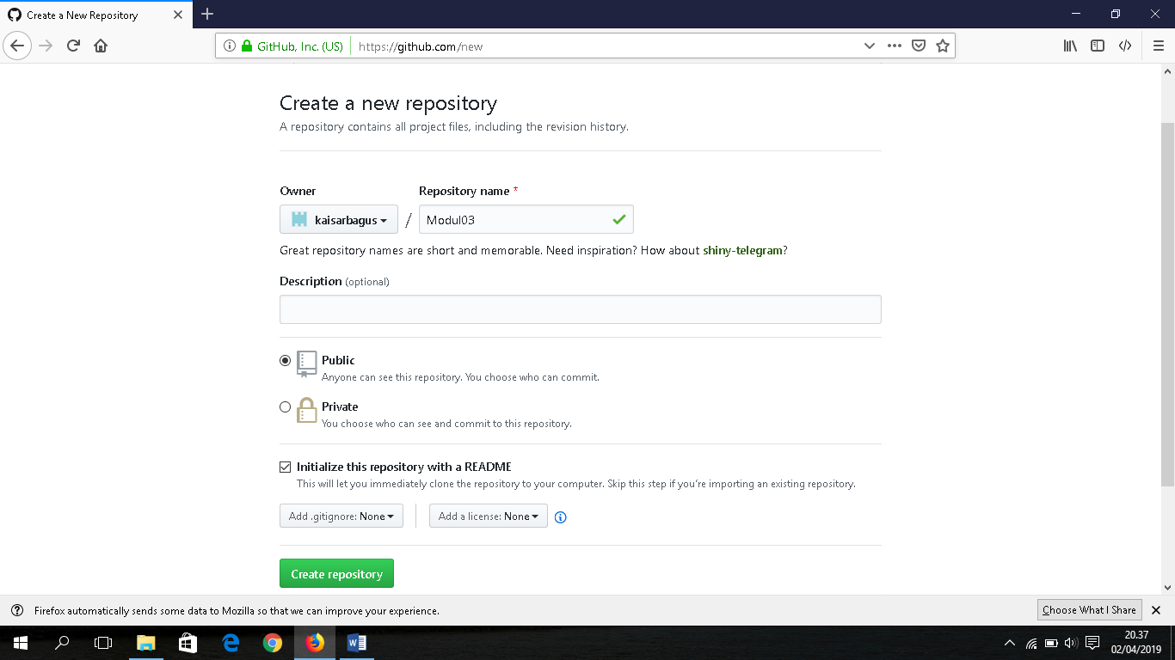

**Drag file yang ingin di upload sekaligus commit**

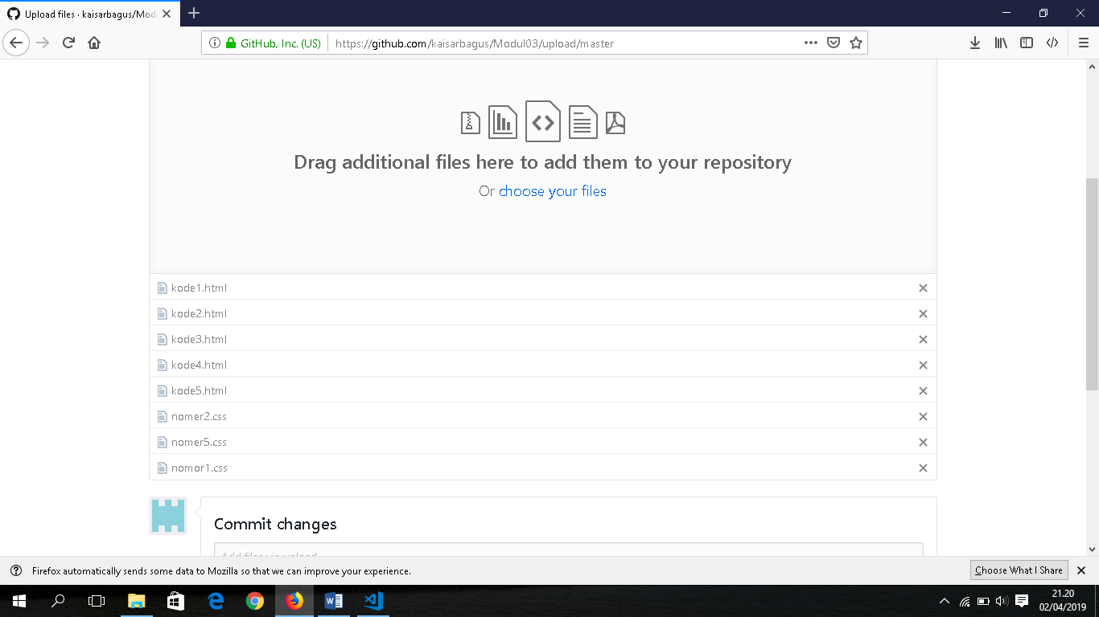

**Setelah itu pilih commit change.**